Ideation Phase
Empathize & Discover

Date | 4 July 2026
Team ID
Project Name | Darshan Ease
Maximum Marks | 4 Marks

Empathy Map Canvas:
An empathy map is a simple, easy-to-digest visual that captures knowledge about a user’s behaviours and attitudes.

It is a useful tool to helps teams better understand their users.
Creating an effective solution requires understanding the true problem and the person who is experiencing it. The exercise of creating the map helps participants consider things from the user’s perspective along with his or her goals and challenges.
Example:


Reference: https://www.mural.co/templates/empathy-map-canvas

Example: Darshan Ease (Temple Darshan Booking Application)
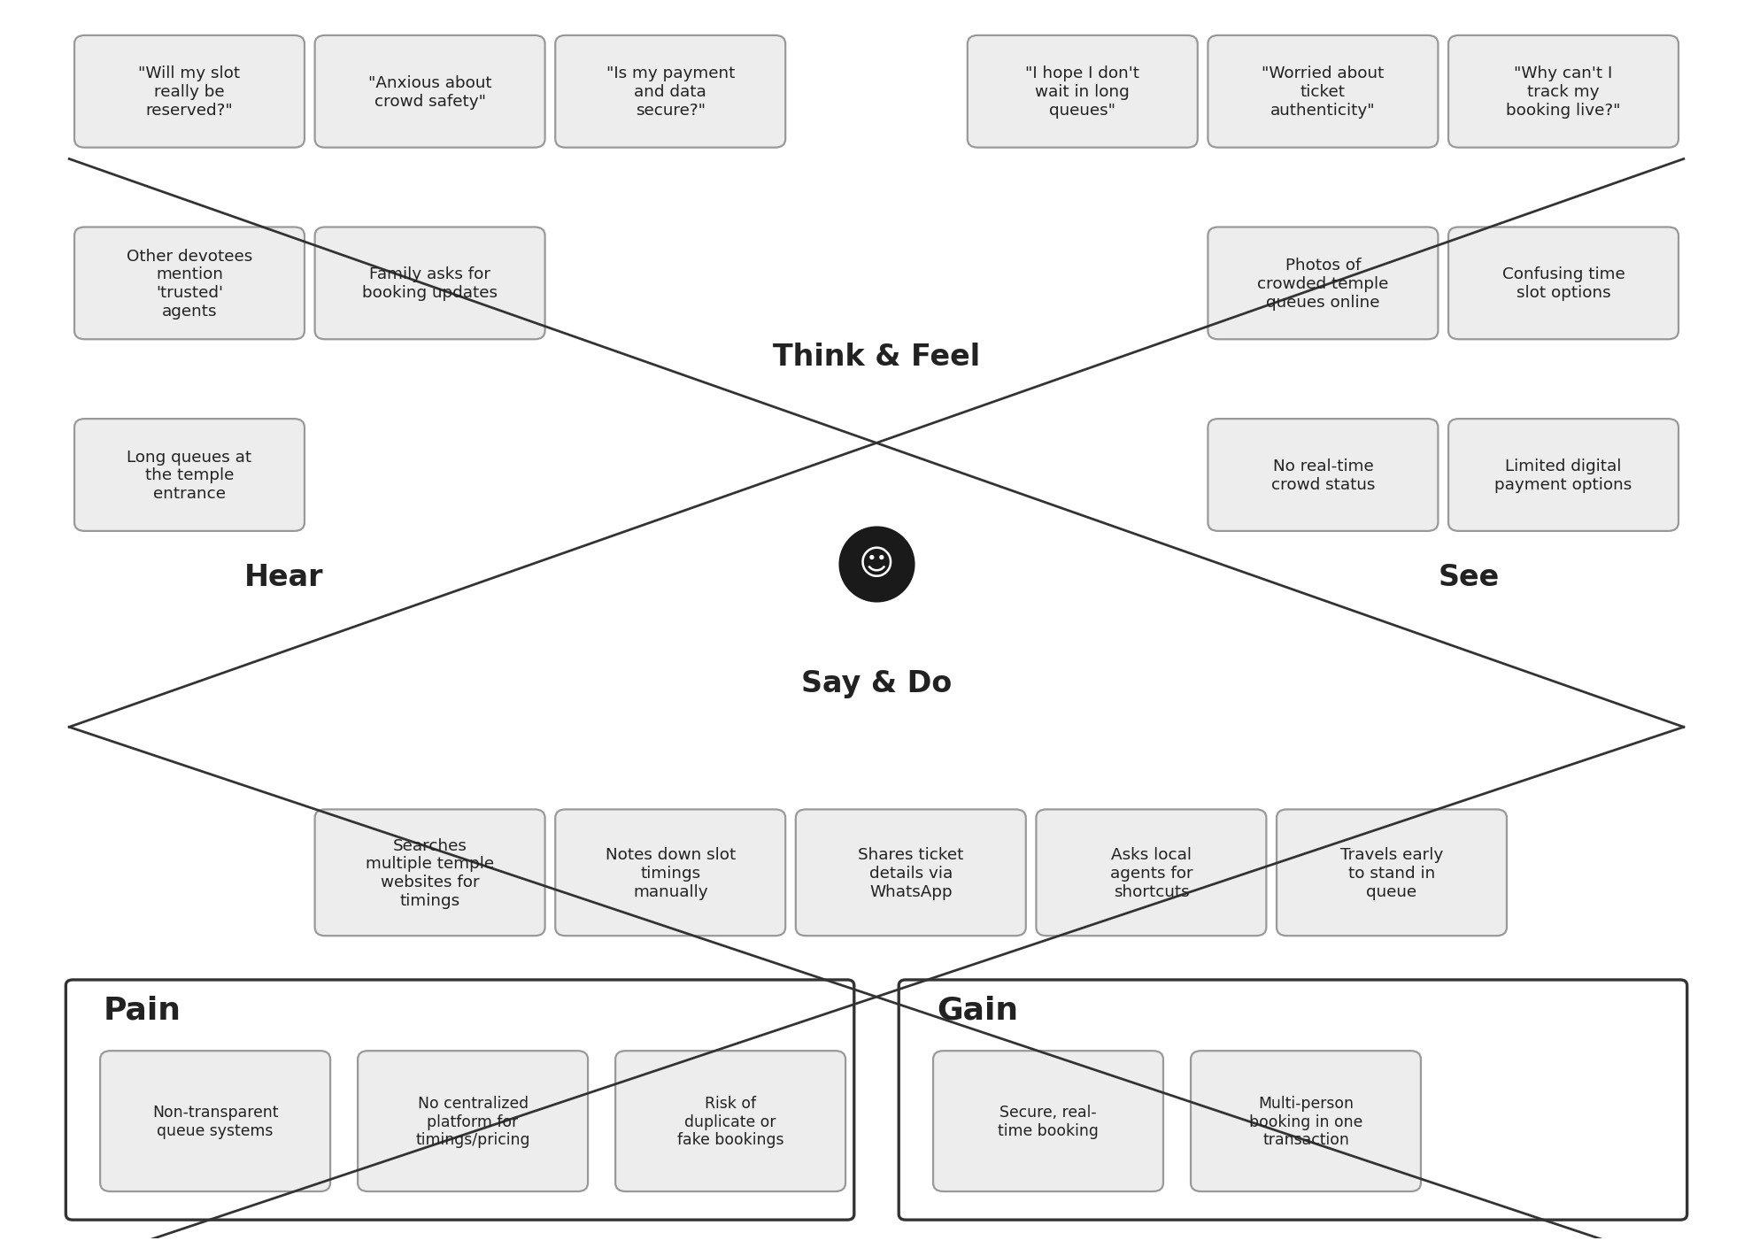

Empathy Map: Darshan Ease (Devotee Persona)
User Persona: Devotee planning a temple darshan visit. The empathy map below is built for Darshan Ease, based on the devotee’s behaviour and attitudes when trying to book a temple visit.